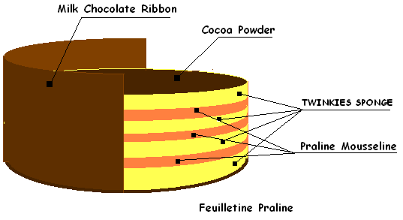
TWINKIES or SPONGE CAKE  2 Cup Flour  1-1/2 Cup Sugar  1 Tablespoon Baking Powder  1/2 Teaspoon Salt  1/2 Cup Vegetable Oil  3/4 Cup Cold Water  2 Teaspoon Vanilla  7 Egg Yolks  7 Egg Whites  1/2 Teaspoon Cream of tartar or lemon | In a large bowl, mix the first 4 ingredients.  Make a well and add the next 4  ingredients.  Beat until smooth with a spoon and set aside.  Beat the egg  whites with the cream of tartar until stiff peaks form.  Pour over egg yolk  batter and fold in until well beaten.
OR
- 565 gm 10X Sugar
- 450 gm Egg Yolks

- 1 kg 100 Egg Whites
- 340 gm Sugar

- 300 gm Flour
- 125 gm Corn Starch
- ‘2 tbsp Baking Powder

- 2 ¼ cup Grape seed Oil

