_______________APPLE FEUILLETINE_______________
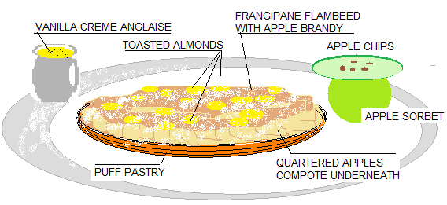
PUFF PASTRY | Roll the dough 1/8 of an inch thick Punch out discs 4 inch diameter Keep these in freezer until needed
APPLE COMPOTE - for 1 kg peeled apples - 50 gm butter - 1 cinnamon stick - 1 vanilla beans (cut in half) - 100 gm sugar  Add for this recipe when totally chilled - 100 gm crème fraiche | Peel Golden Delicious or Gala Apple, Cut in halves, and core them Cut them into ¼ inch dices Put them in stainless pot with the other ingredients and toss them together Tightly seal with plastic wrap (using a rubber band) and cook until the plastic bubble 2 times the size of the cooking ware, It is similar to pressure cooking and this may take no more than 15 or 20 minutes Remove from stove and let sit still sealed The diced apples shouldn’t fall apart
FRANGIPANE  - 1 lb butter (creamy) - 1 lb 10 X sugar - 1 lb blanched almond flour - 10 eggs (cold) | Put the first three ingredients , butter first. Cover the butter with the sugar and almond flour Crack the eggs over the almond flour and turn on first speed for 10 seconds, second speed for 5 seconds, third speed for 10 seconds Put back then onto second speed until the mix becomes fluffy until clear yellow color Using a pastry bag and a medium round tip, pipe some of this mix onto the quartered apples , arranged on the pie over the compote These are ready to be baked right away for a good 30 minutes on a perforated sheet pan (It is also possible to start on a regular baking sheet for 20 min and finish baking on a cooling rack for another 10 to 15 min)
TOASTED ALMONDS  - 1 can of blanched sliced almonds - 1 lb granulated sugar - 300 gm Orange blossom water | Toss the three ingredients together in a large bowl and split them onto two large sheet trays Dry in convection oven at 250F for about 30 min or until they turn light golden color It is very important to toss them on the tray while baking and to prevent them from sticking together because of the sugar caramelizing
GREEN APPLE SORBET - 1 kg 500 Cold Green Apple Granny S - juices of 2 lemons - Sorbet syrup (675 gm sugar / 500 gm water / 75 gm corn syrup / 3 gm pectin ) | Cut apples in halves, skin on, and core them Quarter them and toss them with the lemon juice Juice them quick, add the syrup (to taste) and spin in ice cream maker If made quick and having the apples chilled the day before, the sorbet should show out green
VANILLA CRÈME ANGLAISE  - 1 Qt Milk - 1 cup Heavy Cream - 2 vanilla beans - 1 cinnamon stick - ½ tbsp white peppercorn crushed coarsed - 10 to 12 yolks - 1 cup (225gm) sugar - pinch of sea salt (optional) | Bring the milk and cream to a boil a first time infusing the vanilla beans ,the cinnamon stick and white pepper.  Beating energetically using a wire whisk, combine yolks and sugar until it turn into lemon color.  Remove the boiling liquid from the flame  Pour some of the boiling liquid over the egg /sugar mixture, mix well and add this mixture back to the remaining boiled liquid.  Put the pan back on the stove over medium heat .  By using a wooden spoon,gently finish cooking the crème anglaise until thick enough to cover the back of the spoon.  The safest way remains to use a thermometer. In this case, turn off the flame when the mixture reaches 84 C / 183 F.  Strain immediately into a bowl over a bath of ice  TIP: by tracing a line with a finger on the cream coated spoon, we should see this line remaining still.

