_______________BANANA FOSTER________________
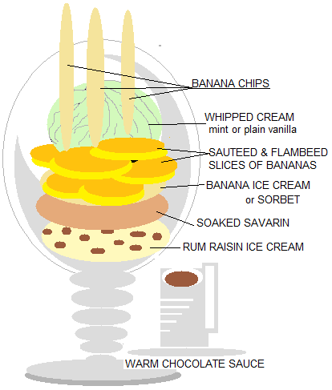
SAVARIN - 1Kg AP flour - 70 grs fresh yeast - 15 eggs - 1 dl hot water - 360 grs melted butter - 20 grs salt - 60 grs sugar | Dissolve the yeast into lukewarm milk. Shape the flour into a fountain in a mixing bowl. Add the eggs, sugar, salt and dissolved yeast in the middle Knead in mixer with the hook adapter. Knead until the dough stops sticking to the sides of the bowl Add the chunks of soft butter ...cover with a clean cloth and keep aside in a warm place until the dough doubled in volume. When the dough has risen... ...tear it with the back of your hands. Grease a large savarin pan or individual baba pans Fill up each pan to 3/4 of its capacity. Let it grow again until the dough reaches the rim. Glaze the surface of the babas with egg yolks.. ...and bake in a warm oven at 180°C (356°F) for 15 to 20 minutes. The babas will rise and turn golden. When baked take out of the oven and unmold on a rack. Let it cool. The babas are ready for use an d to be soaked in the syrup flavored with the dark rum….the longer the better.
RUM RAISIN ICE CREAM -1 ½ quart Milk  - 1 quart ½ & ½  - 2 vanilla beans  - 100 gm light corn syrup  - 200 gm sugar  - 4 gm Ice cream stabilizer (agar agar)  - 1 can (400 gm) sweet condensed milk  - 1 box Golden raisins | Combine milk/half & half/corn syrup to a boil infusing the vanilla beans. Mix sugar and stabilizer and add it to the boiling liquid. Wait for the boil again. Turn off flame and add the condensed milk. Let cool and refrigerate over night before spinning in ice cream maker  Macerate the golden raisins in Dark Rum (Myer’s) for a day or two When spinning the ice cream, at the end of the cycle, incorporate in the ice cream and out of the machine, the quick drained Golden Raisins . Store in freezer right away.
BANANA SORBET - 1kg peeled bananas - 1 lime juice (or 2) - Sugar syrup (to taste-recipe ** at “Apple Feuilletine”) | Blend the bananas , adding the lime juice(s) Add the syrup , amount according to taste Put in ice cream maker and freeze
WHIPPED CREAM -1 qt heavy cream - 400 gm vanilla simple syrup or mint | Using a syphon
BANANA CHIPS - 300 gm purreed bananas - 2 lime juices (little than the sorbet) - 20 gm potato starch | Process the three ingredients together Thinly spread the mix onto “Silpat” and dry in convection oven at 180 F for at least one hour When ready remove from trays and store in sealed boxes
CHOCOLATE SAUCE - 1 liter water – 600 gm sugar – 1 qt Heavy cream – 400 gm cocoa powder | Bring water and sugar to a boil Add the cream, bring back to the boil Incorporate the cocoa powder using a whisk and bring back to the boil stirring constantly

