BANANA SHORTCAKE
_______________SABLEUSE_______________
- 660 gm (34) egg yolks  - 2 whole eggs  - 1 kg sugar  - 1 kg butter  - 300 gm all purpose flour  - 300 gm corn starch | Whip yolks and sugar until butter is melted. Add melted butter  Then add flour and cornstarch, sifyed together .  Linen two large sheet pans with butter and parchment paper.  Share the mix onto trays  Bake @ 315F for about 25 minutes.  Let cool and refrigerate
___________PRALINE CRISPY RICE___________
- 500 gm Praline paste  - 250 gm Milk Chocolate  - 50 gm butter  - 400 gm Rice Crispy | 1-Melt Praline, butter and chocolate together over double boiler  2-Once melted, add rice crispy  3-set mold to 12”X22”  4-Butter parchment on a 2 whole sheet trays  5-Spread praline/rice crispy mix evenly within mold  6-Put into fridge until ready to use
______________MOUSSELINE_______________
MOUSSELINE  - Pastry cream  - Butter cream  PASTRY CREAM  - 1 quart Milk  - 2 eggs  - 80 gm pastry cream powder  - 225 gm sugar  BUTTER CREAM  - ½ cup corn syrup  - 1 lb sugar  - 1 cup water  - 250 gm egg whites  - 2 lb butter | MOUSSELINE  Combine pastry cream and butter cream until homogenized  PASTRY CREAM  Bring milk to a boil  Mix eggs, powder and sugar until smooth  Add part of boiling milk over egg mixture  Combine everything and bring back to the boil  BUTTER CREAM  Cook corn syrup , sugar and water up to 121C  In mixer start egg whites on 2nd speed  When sugar is about ready , turn mixer onto 3rd speed  Gently pour sugar over beating whites  Let work until lukewarm  Add diced cold butter to still running meringue (swiss) and let turn until well homogenized

____________PABANA JELLY____________
- 1 kg Pabana puree  - 500 gm Sugar  - 11 gelatin sheets | Bring Pabana puree to the boil  Add the sugar  Add the gelatin  Mix well and dispense in plastic container  Refrigerate
_______MILK CHOCOLATE SORBET________
- 1 galon (3600ml) water  - 1150 gm sugar  - 1 vanilla bean  - 4 tbsp coffee extract  - 4 ½ cup dark cocoa powder  - 1 kg Milk Chocolate | Bring water, sugar, vanilla bean to the boil  Add cocoa powder and bring back to the boil, constantly whisking  Remove from flame and add the milk chocolate and coffee extract  Refrigerate over night before spinning in ice cream machine

______________MONTAGE_______________
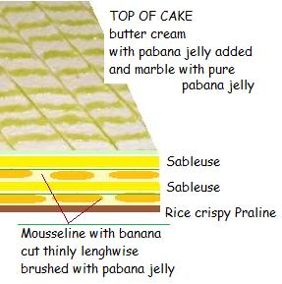 | 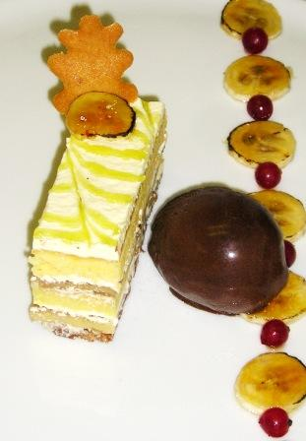
______________
BANANA SHORTCAKE

