________CARROT CAKE________

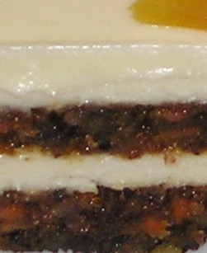
____________________________Sponge
This recipe will fill 5 to 6 1/2 sheet trays
- 400 gm _____1kg600 Sugar
- 4 __________16 Eggs
- 1__________4 Bananas
- ½ _________2 tbsp Vanilla extract
- 1½ ________3 pint Corn Oil
- 125 gm______500 gm All purp. Flour
- 125 gm______500 gm Roasted Filbert Flour
- 2 gm _______10 gm Baking Soda
- 10 gm ______40 gm Baking Powder
- 1 gm _______5 gm Sea Salt
- 5 gm _______20 gm ground Cinnamon
- 75 gm ______300 gm Walnuts
- 1/3 _________ 1 1/2 boxes Golden Raisins

___________________________Frosting
for a three layers ,1/2 sheet tray cake
- 1/2 lb Butter
- 2 lb Cream cheese
- 2 lb 10 X
- Vanilla

