CHARLOTTE VANILLA CHOCOLATE
VANILLA LADY FINGERS  - 1 - 17 yolks + 1 whole egg  - 1 - 250 gm Sugar  - 1 – 1 tbsp Orange blossom water  - 1 – 1 tsp Vanilla extract  - 2 - 300 gm AP Flour  - 2 - 110 gm Corn Starch  - 3 - 17 Egg whites  - 3 - 160 gm Sugar | Having a spare mixing bowl tremendously improve the operation  In kitchen Aid, mix on high speed, Yolks/single egg/sugar until light and lemon color. Add flavoring before shutting off.  In the spare mixing bowl, beat the whites and add the sugar at the end to obtain the hard peaks  Mix a small amount of the firm whites to the yolk/sugar mixture. Pour this mixture over the sifted dries (2-) and gently fold in.  Add the remaining whites and homogenized using a rubber spatula.  Garnish the pastry bag & large tip and pipe the lady fingers over sheet trays linen with parchment paper .  Generously sprinkle confectioners sugar over the lady fingers and let sit for 7 to 8 minutes before baking  Bake at 325 F for 12 to 14 minutes ( rotate the trays after the first 8 or 9 minutes)
CHOCOLATE LADY FINGER  - 1 - 17 yolks + 1 whole egg  - 1 - 250 gm Sugar  - 2 - 250 gm AP Flour  - 2 - 110 gm Corn Starch  - 2 - 50 gm Cocoa Powder  - 3 - 17 Egg whites  - 3 - 60 gm Sugar | Same as above  The only warning would be not to over mix because of the reaction when adding cocoa powder to the mix.  For some reasons cocoa powder and beaten egg whites find it hard to co-inhabit together
GRAND MARNIER SYRUP  - 1 liter Water  - 1 kg Sugar  - 1 cup Grand Marnier Liquor  CANDIED ORANGE ZEST  - Orange Zest  - 500 gm Water  - 500 gm Sugar | Bring sugar and water to a boil and let cool completely  Add Grand Marnier and Using a spray bottle, spray the flavored syrup on the lady finger, side and bottom  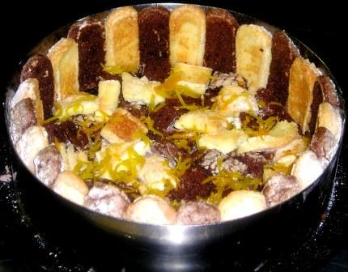
VANILLA BAVARIAN CREAM  - 1 - 1 liter milk  - 1 - 2 vanilla beans  - 2 - 240 gm (12) Egg Yolks  - 2 - 300 gm Sugar  - 3 - 12 Gelatin Leaves  - 4 - 1 liter Heavy Cream (Whipped)  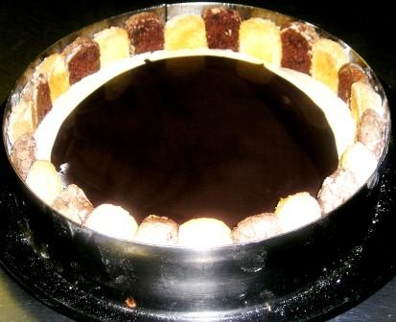 | Bring the milk to a boil, infusing the vanilla beans  Meanwhile mix well yolks and sugar together until light lemon color  Add a part of boiling milk onto mix yolk/sugar and combine every in a cooking pot.  By using a wooden spoon,gently finish cooking the crème anglaise until thick enough to cover the back of the spoon.  The safest way remains to use a thermometer. In this case, turn off the flame when the mixture reaches 84 C / 183 F.  Strain immediately into a bowl over the presoaked and well drained gelatin leaves  Keep over a bath of ice until thickening  Finally add the whipped cream and fill in the mold, half way  Before being ready to cover with the Chocolate mousse, place a thin disc of tempered Chocolate onto the vanilla cream like it shows below.
CHOCOLATE MOUSSE  - 1 - 320 gm (16) Egg Yolks  - 2 – ¼ cup Corn Syrup  - 2 – 360 gm Sugar  - 2 – ½ water  - 3 – 600 gm Chocolate Dark 66%  - 4 – 1200 ml Heavy Cream, Whipped  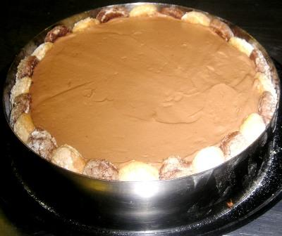 | Cook corn syrup/sugar/water until soft ball 121C.  Pour the cooked sugar over the beating yolks and let work until almost cold.  Add the melted chocolate (very warm) and mix energetically .  Add a small amount of the whipped cream to the chocolate/yolks/sugar mixture, mix well and add it to the whipped cream.  Gently fold in the ingredients until smooth and homogenized.  Share the mousse between the charlotte molds and smooth it up using an offset spatula.  Refrigerate before removing ring mold.
CHOCOLATE CURLS  - Semi-sweet Chocolate | 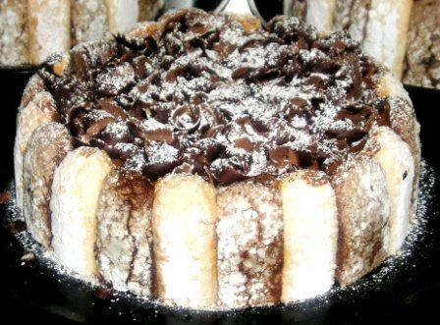
CHOCOLATE SAUCE  - 1 - 1 liter Water  - 1 – 600 gm Sugar  - 1 – 1 quart heavy Cream  - 2 – 400 gm Dark Cocoa Powder | Bring water/cream/sugar to a boil  Add the cocoa powder, whisk well and bring back to the boil.  Remove from flame at the boil  Let cool completely in keep refrigerated until needed.
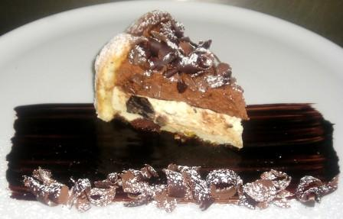__________________________
CHARLOTTE VANILLA CHOCOLATE

