CHECKERBOARD SUNDAE

COCONUT AGAR  - 1 can (400 gm) coconut milk  - 300 gm water  - 90 gm sugar  - 1 ¼ sticks (large) Agar “Kanten”  - vanilla extract (optional)  Bring coconut milk, water and sugar to a boil.  Meanwhile , soak the Agar in cold water just enough to make it soft. Squeeze it between hands to extract the water.  Add the gar to the boiling liquid and let cook slowly until the gelatin is totally melted .  At the end ,and before pouring the coconut jelly into forms , blend it for a few seconds with a hand blender if necessary.  Pour liquid into a large tin and let cool.  Refrigerate before removing and portioning.  STRAWBERRY AGAR  - 700 gm Strawberry water  - 1 ¼ sticks (large) Aghar “Kanten”  Strawberry Water  - 1 kg strawberries  - 1 lime  - 1 orange  - 300 gm sugar  - 1 ½ liter mineral water  Wash the strawberries with their stem in cold water.  Let them sit in the water bath for 15 mn, and drain them  well over a colander.  Cut them into 4 pieces, add lime and orange, sliced,  then the sugar and mix together slowly.  Let sit for an hour or until the sugar and strawberries  form a syrup.  Add the water and stir well.  Keep in the fridge for 24 hours.  Next day strain the liquid through a colander and repeat  the operation using a triple layer of cheese cloth.  Pour the strawberry water into a bain-marie and keep  refrigerated. | 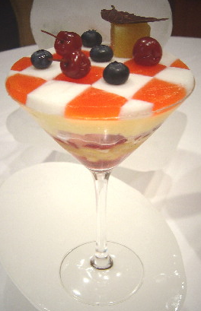  ________MONTAGE________  In the order eaten  Checkerboard  Coconut / Strawberry  Lemon candy ice cream (repeat)  Fruit Cocktail  Mango / Pineapple / ?  Sour orange Granita (repeat)  Lemon Candy Ice cream  Sour orange Granita

CHECKERBOARD SUNDAE
__________page 1__________

LEMON CANDY ICE CREAM
LEMON ICE CREAM ________ 3 third  - 180 gm butter  - 500 gm sugar  - 10 lemon zest  - 13 eggs  - 225 gm yogurt  - 625 gm lemon juice  - 1 tsp vanilla  + PASSION FRUIT JUICE___ 1/3  + MANGO PUREE__________ 1/3  + GUAVA JUICE____________ 1/3  + Sorbet Syrup (to be determined)  - 2 kg 700 sugar  - 2 liter water  - 300 gm light corn syrup | Step 1: LEMON ICE CREAM  Melt butter in stainless steel pot , add the sugar and stir until combined  Add the lemon zest and remove from flame.:  Add the eggs (beaten into omelet) and stir energetically.  Cook over low heat stirring constantly until the mix will coat the back of a spoon or spatula.  Immediately add yogurt  Strain into a plastic container or a “non reactive” container to citrus acid.  Finally add the non strained lemon juice.  Step 2 : Combining all  Add the fruit purees to the Lemon base.  Rectify the sweetness by adding some syrup if necessary.

CHECKERBOARD SUNDAE
_______page 2 & last________

