CHERRY JUBILEE
Jubilee__ Sorbet __ Pistachio Sabayon __ White chocolate thread
_____________________________________________________

JUBILEE
- 1 bottle of Port Wine  - 1 kg Sugar  - 1 liter Water  - 1 kg Black Currants “Cassis”  - 2 drops pure almond extract  - 5 lbs pitted Cherries | Reduce Port wine. A foam will rise when ready.  Add water, sugar, and “Cassis” puree and bring to a boil.  Add the almond extract.  - Before service, bring some of the jubilee to a boil and add the pitted cherries for that same day only  – or as close as possible.

SORBET
1 kg Cherry Frozen puree  Sorbet Syrup (tbd)  - 2 kg 700 sugar  - 2 liter water  - 300 gm light corn syrup  - 6 gm stabilizer | Add some sorbet to the Cherry puree (defrost)  Do it gradually to determine how much exactly is needed . this would really help for the next time.  Then spin in ice cream maker  or simply freeze this mixture in the container fit to be adapted to “PacoJet”

PISTACHIO SABAYON
- 12 egg yolks  - 1 whole egg  - 200 gm sugar  - 75 gm Pistachio paste “Mec 3”Blend  - 1 bottle Champagne  - 450 gm half & half  - 200 gm heavy cream | In a stainless steel pot , bring the first five ingredients to a boil, constantly stirring using a wire whisk.  When ready dispense this mixture in a stainless steel bowl over ice and let cool completely.  Just before storing, add the heavy cream and half & half.  Keep refrigerated.  Dispense some of the sabayon in a syphon (whipped cream canister) .

_________________CHERRY JUBILEE____________page 1_____
Jubilee__ Sorbet __ Pistachio Sabayon __ White chocolate thread

WHITE CHOCOLATE THREAD
- Valrhona white Chocolate | Tempering the chocolate  Melt the chocolate in a stainless bow lover double boiler.  When the chocolate is partly melted , gently stir in using a rubber spatula.  Let sit until temperature goes down reaching around 72 to 74 F.  Fill a parchment paper cone with the chocolate and start piping it onto sheet of acetylene (plastic).  Wait until it sets and keep in a cool place  If the kitchen doesn’t offer this kind of environment you may store in the freezer (not the fridge)

DECO
- Pistachio brittle  - Chocolate Thread | Make a simple dry caramel with  30 gm light corn syrup, 150 gm sugar, 20gm butter, add the pistachio and spread over a silpat and allow the cool down before using.  As explained above

MONTAGE | PHOTO
In a deep plate arrange some cherries(warm),  Partly cover with the sabayon,  Dispose a scoop of cherry sorbet in the middle,  Stick by gently pushing down the golden thread onto the sorbet __and maybe, why not another cherry in its center with a green colored pulled sugar stem. | 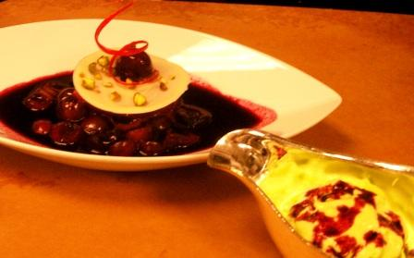

_________________CHERRY JUBILEE____________page 2 & last_____
Jubilee__ Sorbet __ Pistachio Sabayon __ White chocolate thread

