_______________CHESTNUT CHESS_______________
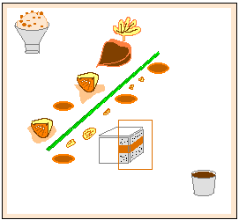
__________________________________ CHESTNUT with LEAF
 Chestnut paste in a shape of a Chestnut , Chocolate coated
Leaf in Cigarette cookie batter (or nut free Tuile)

__________________________________ “Mont Blanc” IN A BOX
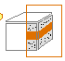Vanilla “Chantilly”(Sweet whipped cream)
Chestnut paste done from raw frozen Chestnut from Italy, cooked in Milk and cream , little sugar and Vanilla beans (the cooking liquid become the broth for the making of the Ice-cream}
5 small squares of crispy meringue forming the side of a box

___________________________________”MARRONS GLACES”
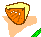 Candied Chestnuts sugar iced

___________________________________KUMQUAT “Swiss Riviera”
Thin slices of Candied Kumquat filled with Carrot cake (using the best toasted Filbert Flour)
___________________________________WALNUT BRITTLE
Pieces of Walnut Brittle
Eric Hubert__ 10-21-04
___Page 1___

___________________”ANGELIQUE” of CELERY
Candied Celery

___________________The ICE-CREAM
 Chestnut Ice-cream done with the cooking liquid of the Chestnuts , more paste , Maple syrup (as a stabilizer), Rum (for extra flavor) , piece of Walnut Brittle
No eggs
___________________A SAUCE
Chocolate ,warm with a hint of spices

Eric Hubert__ 10-21-04

___page 2___

