_________MILLE (1000) FEUILLES au CHOCOLAT_________
CHOCOLATE PUFF PASTRY / MILK CHOCOLATE MOUSSE / DARK CHOCOLATE CHANTILLY
WARM RASPBERRIES / ICE PRESENTATION / ICE-CREAM & SORBET

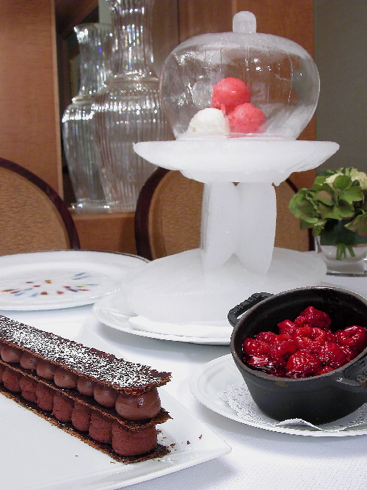 | 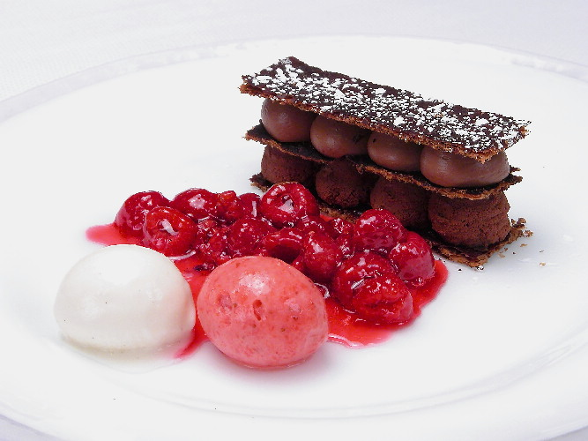

_________________________CHOCOLATE PUFF PASTRY
· Regular puff pastry (recipe,click) , give an extra turn with cocoa/10X mix( ½ & ½ )
· Roll the dough very thin using the same cocoa/sugar mix with abundance
· Lay the sheets of chocolate dough onto parchment paper (for ½ size baking sheet trays)
· Keep in freezer until needed .
· put each sheet of dough on the back of a tray, by turning it upside down.. Cover with another ½ sheet of parchment paper . cover with two trays (to prevent the dough from rising to much)
· Bake at 300F for 20minutes on high blow.. And another 15 min on low blow · Allow to cool before using ,
Use a ruler to cut the dough in a way to obtain even strips of mille feuilles

_________________________MILK CHOCOLATE MOUSSE
- 1 Qt heavy cream
- 1 Qt milk chocolate
· Bring the cream to a boil and add chopped chocolate to it. Mix well using a whisk. Then , keep cover in fridge until cold and needed.
· Put the amount of ganache ,needed for the confection of the Mille Feuilles, in the KitchenAid ; and by using the whisk , just give a few turn of machine , enough to give some emulsion and make the ganache look like a rich mousse.
· Fill up in bag and use when needed.

_________MILLE (1000) FEUILLES au CHOCOLAT____ page 1_____

_________________________DARK CHOCOLATE CHANTILLY
- 1 Qt heavy cream
- 450 grs (1 lb) dark chocolate 65 or 66%
· Whip the cream until still very soft
· Add melted chocolate at once in the center of cream and stir energetically
- by using a rubber spatula
- by only stirring in the center until the chocolate is completely incorporated to the cream
- at last , delicately , fold the rest of the cream from side of bowl
· put the chocolate “Chantilly in a bag and pipe onto Mille Feuilles when needed.:

_________________________WARM RASPBERRIES
Heavy syrup learn more about syrups >>> click here
- 150 grs corn syrup
- 1 kg sugar
- 400 grs water
· Bring all ingredients to a boil in a stainless steel pot
· Dispense the syrup in several plastic or stainless steel container and seal well.
· For each order, pour some of the syrup in a hot skillet, add a little piece of butter (optional), wait for the bubbles , drop the raspberries , coat them with the syrup ,using different motions and serve on the side pot or onto plate.

_________________________ICE PRESENTATION
The Ice sculpture
· the socle : different pieces of molded ice , polished and assemble together to create an harmonious combination
· the cloche: party balloons filled with cold water, standing into a bowl and kept in freezer for a certain amount of hours (10 to 12) .
After this period, destroy the balloon using knife or scissors , dig a hole on the to
and pour out the unfrozen water.
Using a hot tray or iron, polish the top of the ice until even.
Turn the ice down side –up , and stick on the top a small knob of ice by spraying
some water

_________________________ICE-CREAM & SORBET
Vanilla ice-cream
Mix with milk , cream, corn syrup, Agar-Agar , sugar and fresh vanilla beans ONLY
No eggs
Strawberry sorbet
Fresh strawberries, corn syrup, sugar syrup, lemon juice

_________MILLE (1000) FEUILLES au CHOCOLAT____ page 2 & last_____
CHOCOLATE PUFF PASTRY / MILK CHOCOLATE MOUSSE / DARK CHOCOLATE CHANTILLY
WARM RASPBERRIES / ICE PRESENTATION / ICE-CREAM & SORBET

