GUAVA & PAPAYA CREAM CHEESE TERRINE

THE FRUITS
PAPAYA  - orange zest  - red (Spanish) Paprika  (for later when building the terrine)  GUAVA | Slice the papaya 2cm (1/8 inc) thick.  Arrange them in a hotel pan in multi layers.  Between each generously sprinkle granulated sugar, some orange zest
THE CREAM
- 1 lb Cream cheese  - 1 cup whipped cream  - 50 gm Confectioners sugar  - 3 Gelatin leaves | Soften cream cheese and sugar by combining both in mixer.  Melt pre soaked gelatin and melt it with 1 tsp vanilla extract and 30 gm heavy cream.  Add whipped cream right away.
THE SORBET
- Papaya macerating syrup
- Guava puree
- Condensed milk

MONTAGE | PHOTO or Drawing
Linen a terrine mold with a double layer of plastic wrapping.  Spread a thin layer of cream cheese mix on each side.  Alternatively arrange sliced macerated Papaya inside mold and guava.  Sprinkle some paprika on the papaya slices.  Put just enough cream between layers to hold the fruits together. | 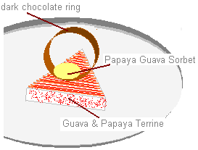

GUAVA & PAPAYA TERRINE

