___GUIMAUVE KISSES___
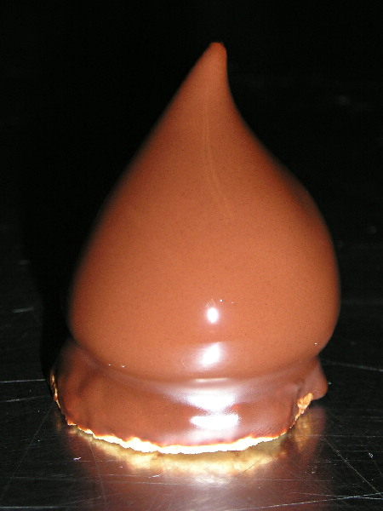
_______"BOUDOIRS"_______  - 90 gm egg yolks  - 225 gm whole eggs  - 180 gm blanched almond flour  - 275 gm sugar  - 2 tbsp Orange water  - 1 tsp vanilla extract  --------------------------------  - 170 gm all purpose flour  --------------------------------  - 220 gm egg white  - 100 gm sugar  - 1 tsp fresh lemon juice  ---- about 1000 pieces ----  Bake at 300 F for 15 min  on low blow | - In mixing bowl, beat together :  yolks , eggs almond flour and sugar  until creamy and light lemon color  - Add at the end the OB water and vanilla  - Sift the all purpose flour in the separate bowl  - Beat the whites until stiff finishing with the sugar then the lemon juice.  - Add the sifted flour into eggs mixture as well as a part of the firm whites  - Finally, fold in the rest of the whites  - Pipes dots of batter onto parchment paper (6 X 10)  - Bake at 300ºF for 13 to 15 min
_______MARSMALLOW_______
- 625 gm egg whites
------------------------
- 150 gm light corn syrup - 625 gm sugar
- water ( about 1 cup)
- flavors 1 tsp - 14 leaves gelatin

---- pipe about 600 ----

__page 1__

In a stainless steel pot cook together the ingredients above the line.
- When the sugar mixture reaches the boiling point , turn the mixer on 2nd speed
- Meanwhile, count the gelatin and soak it in cold water just as long as necessary to make it soft . Then strongly drain the water away by squeezing it between hands . Keep on the side
Also keep in mind that if the gelatin is over soaked . it becomes difficult to drain it appropriately ,and by adding it so to the cooked sugar , it will dramatically change its temperature
- When the sugar seems to reach its cooking level (149C or 300F) , keep an eye on it , then add the vanilla extract and the gelatin . Stir well using a wooden spatula
- Meanwhile , turn the mixer on 3rd speed and be ready to pour the hot mix into firm whites.
- When the sugar is added to beating whites, let turn on 3rd speed until lukewarm
- Insert a plain piping tips into a piping bag and fill in with the marshmallow .
- Pipe a small peak of the meringue on each little round cookie
- Wait for about 10 min before applying the chocolate coating by dipping upside-down the kisses one by one into the tempered chocolate

* the cooking level of the sugar should be the “hard ball”(121°Celsius or 250°F) but because of the adding of the gelatin that bring down the temperature , it is necessary to reach the “hard crack” (14__

Eric Hubert __ 2004
__page 2__

