KIWI TART
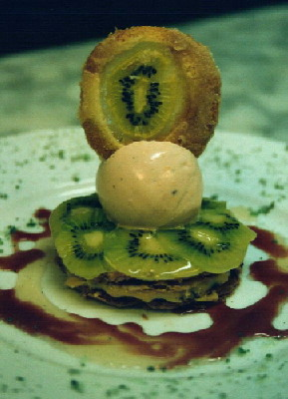

Milk Marmalade
-4 Cans of Coconut Milk -Bring vanilla beans and coconut milk
-4 Cans of Evaporated Milk a boil
-4 Cans of Condensed Milk -Add the evaporated milk and boil
-4 Vanilla Beans -Add condensed milk and constantly
stir until boiling again
-Reduce until color changes to clear
golden

Kiwi Cookie (Tuile #1)
-800g Sugar –Kiwi slices cut thinly and part
-750g All Purpose Flour drained on paper napkins
-625g Egg Whites
-750g Butter (melted)

Lemon Curd Ice Cream
-700g Butter –Melt butter and sugar together
-2K Sugar –Add lemon zest, remove from flame
-50 Lemons Zested –Add the eggs (beaten into omelet)
-50 Eggs –Stir energetically
-1qt Yogurt –Cook over low heat stir, constantly
-2 ½ L Lemon Juice until mix covers back of spoon
-1tbsp Vanilla Extract –Immediately add yogurt, lemon juice

Spicy Sauce
-1 Pineapple –Use all of the pineapple
-4 Limes –Put all ingredients together in pot
-2 Vanilla Beans –Bring to a boil
-1 Clove –Simmer for approximately 2 minutes
LIASON -Strain through fine mesh strainer
-1 ½ L Water –Bring back to a boil
-Cornstarch -Add water/cornstarch solution
thicken the liquid

KIWI TART

