BITTER CHOCOLATE MOUSSE
Cherry and chocolate ice cream
Warm Cherry compote

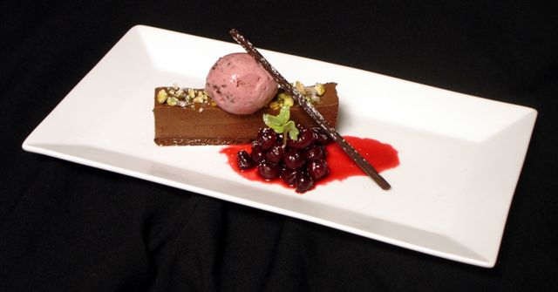

Bitter Chocolate Mousse
470 g 66 % chocolate
215 g milk
3 gelatin sheets
435 g cream
Melt the chocolate. Soak the gelatin. Bring the milk to a boil and add the gelatin. Temper into the chocolate. When cool and the whipped cream.
Pour onto devils food cake.

Devils food cake
1# butter
2#5 oz. sugar
8 oz. cocoa
7 eggs
1# 12 0z. flour
½ oz. baking soda
½ oz. baking powder
½ oz. salt
1 qt. water
Cream the butter, sugar, and the cocoa. Add the eggs and scrape. Add the dry with the water and mix until smooth. Make sure to scrape the bottom of the bowl. Add 4 c to a sheet pan and bake at 325 turning every 2 minutes. Press when finished.

Black forest ice cream:
1 qt. cream
2 c milk
10 oz. sugar
10 oz. yolks
585 g cherry puree
52 g kirsch

Make a base with the cream, milk, sugar, and the yolks. Measure out 1000 g base and add the cherry and the kirsch. When complete and churned pipe into warm 66 % chocolate whisk to make fine shreds.

Cherry Compote:
20 cherries
20 g sugar
10 g butter
6 g Kirsch
Cook the cherries with the ingredients until tender. Chill over ice.

