CHOCOLATE SOUFFLE with CARAMEL ICE CREAM
___________________________________________

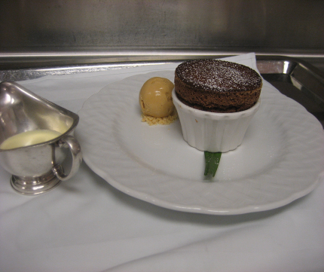

Chocolate soufflé
24oz chocolate
2oz sugar
3tbl corn starch
6oz crème fraiche
9no egg yolks
25oz egg whites
41/2 butter
3oz water
7oz sugar
Bring a pot of water to a boil. Place a bowl over the water and melt the chocolate, butter and crème fraiche, let sit at room temperature. In a kitchen aid mixer whip the yolks, water, and 2oz. Sugar to full volume and fold half into the chocolate mixture. Fold in the corn starch and the rest of the yolks. Place the whites and the 7oz, of sugar in a Hobart mixing bowl and heat 110 degrees over the water. Whip on speed 2 full volume. Gently fold the whites in 3 parts into the chocolate mixture. Butter and sugar ramekins. Scoop soufflé batter into the ramekins using an ice cream scoop and level. Bake 400 degrees for 10 minutes.
Caramel ice cram
4 ½ c
sugar
1 qt cream
48 yolks
2tbsp corn syrup
3 qt milk
1 ½ c sugar
2 c water
3tsp vanilla extract
1 ½ tbsp salt
Combine sugar corn syrup and water in a large rondeau boil until mixture turns very dark caramel. Immediately whisk in cream, be careful because the caramel will spatter. Add the milk and bring to a boil, temper in yolks and remaining sugar and return mixture to the stove briefly until it coats a spoon. Pass, and chill in an ice bath. Add vanilla and salt.
Sauce anglaise
500ml milk
500ml cream
150g caster sugar
280g egg yolks
3 no vanilla pods
Boil cream and milk with the vanilla pod. Whisk together the yolks and sugar. Pour boiling liquid over the egg mix,
return to a clean pan and cook out until it coats the back of the spoon.

