CREPES CAFÉ MARTINIQUE
PLOMBIERE ICE CREAM

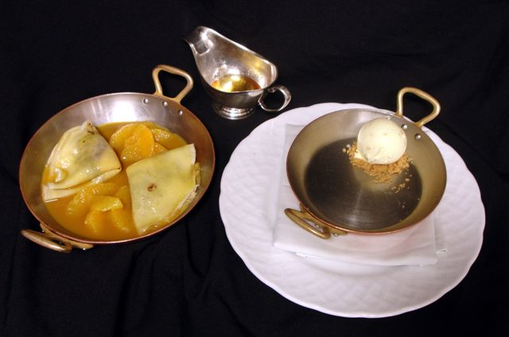

Crepe batter
1 Qt milk
180 gm butter
10 Eggs
180 gm Sugar
500 gm AP Flour
1 tsp Vanilla extract
1 tbsp Orange Blossom water
450 to 550 gm cold milk (the next day)

Bring Milk and butter to a boil (infusing vanilla if fresh beans) In a bowl, combine and mix eggs and sugar. Add the sifted flour, then vanilla extract and OB Pour the boiling milk/butter mix over the egg/sugar/flour mix. Mix well and strain over fine mesh.
The next day, add the cold milk more or less to obtain a fluid batter.
Cook the crepes in a 8 inch skillet, making sure to use the appropriate ladle to duplicate the same thin crepe every time.
2 crepes, filled with the orange pastry cream and grated chocolate will be needed per serving.

Orange Pastry Cream
3 cups fresh squeezed orange juice
2 eggs
I cup milk
110g corn starch
18 yolks
450g sugar
2 vanilla beans
4 tablespoons grand mariner

Bring orange juice and milk to a boil with vanilla, and half of the sugar.
Blanchier yolks and eggs with other half of sugar and grand mariner, sift over cornstarch, whisk until smooth. Temper, after it comes to a boil, cook for 4 min. whisking constantly.
After it sets in frig, whisk it with whisk attachment.

VANILLA Ice-cream
1 ½ qt milk
1 qt half & half
100 gm corn syrup
2 vanilla beans
200 gm sugar
4 gm ice cream stabilizer
1 can (400gm) condensed milk
Candied diced Orange Rinds
Grand-Marnier

Combine milk/half & half/corn syrup to a boil infusing the vanilla beans. Mix sugar and stabilizer and add it to the boiling liquid. Wait for the boil again. Turn off flame and add the condensed milk.
Let cool and refrigerate over night before spinning in ice cream maker.
Cut the orange into small dices (almost the size of the Brunoise). Blanch them 2 times in boiling water cooling them in iced water each time .Between hands, squeeze the water out of the rinds, cover them with new water (make sure to measure the water).Add the same amount of sugar and 1 clove per liter. Bring the whole thing to a boil and let cool completely. Bring the rinds and syrup to a boil again and let cool completely. Repeat this operation 3 or 4 times until the rinds become soft and candied.
Strain the orange rinds, keep the syrup (it can be used for the orange sauce to enhance flavor).
Add some Grand Marnier to the rind (enough to cover them)and let macerate for a few days.
After spinning the ice cream add some of the strained rinds and keep in freezer.

Orange sauce
2 quarts Orange Juice
4 Rinds
1 tbsp chopped Ginger
150 gm Sugar
150 gm honey
1 tbsp Corn Starch
1 tbsp cold water

Peel the oranges to be juiced
Keep the rinds
Combine the first 5 ingredients, bring to a boil and reduce to 1/3
Finish the sauce by making a liaison with the solution starch/water.
Make sure to bring the sauce back to a boil to conclude.

Segment oranges and Grand marine for the flambéing

