GUANABANA SOUFFLE with BANANA SORBET
____________________________________

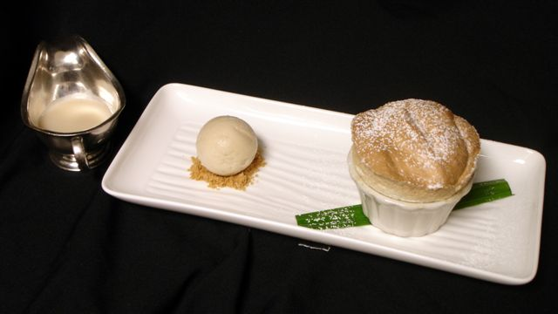
Guanabana soufflé
500g
sour sop puree
500g Egg whites
500g Milk
500g Sugar
250g Sugar
250g Water
100g Pastry cream powder
Butter and sugar 18, 3 ½ “ramekins. Mix the sugar and the pastry cream and powder and add to the raspberry puree. Whisk over a low heat until you form a pastry cream . Place into a large bowl, cover with plastic wrap, and leave at room temperature. Make a Italian meringue with the whites, sugar and water. Cook to 120 degrees. When the meringue is cool, fold into the cold pastry cream. Pipe into ramekins. Bake at 350 degrees for 7 minutes

Banana Sorbet
1kg banana puree
160g Sugar
90g Powder Glucose
35g Dextrose
520g Water

Bring sugar, water, glucose and dextrose to a boil and add the frozen puree. Churn.

Guanabana sauce.
500g Sour sup puree
50g Simple syrup
1no lemon

Mix all together

