Praline Bars

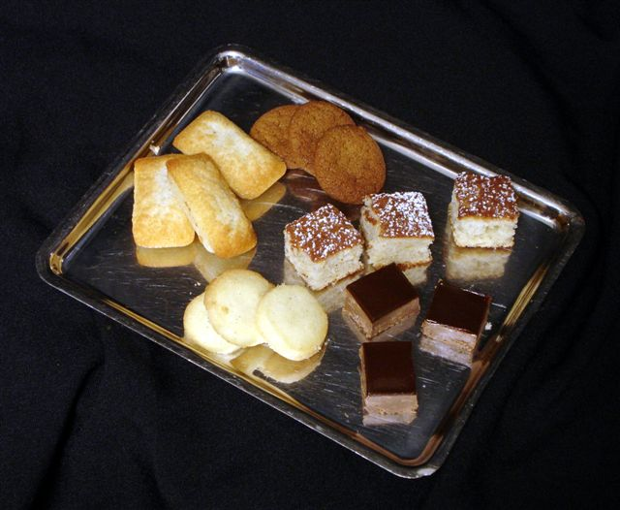

PRALINE BARS

Nougatine:
500 g Sugar (wet sand)
300 g Sliced Almonds, lightly roasted
Bring sugar and water to a medium caramel. Add almonds. Roll between two silpats. Cool completely, and then grind in Robot Coupe. Store in freezer.

Base:
2 lb Gianduja
1 ½ C Feuilletine
½ C Nougatine
2 T Grape seed Oil

Melt chocolate, and then add in remaining ingredients. Quickly pour into half sheet tray lined w/ plastic wrap.
Smooth the top with an offset spatula.

Chocolate Glaze
2# Vahlrona chocolate
1 c Cream
1 c Corn syrup
½ c Grape seed
½ c Glucose
1 c full fat milk
½ qt Heavy cream

Bring the 1 cup of cream, oil, corn syrup, and glucose to a boil. Pour the liquid over the chocolate and mix in the Hobart with a whisk. While mixing add the milk and the last of the cream. When cool add to air tight containers.

Financier cookies
1 pound
10oz icing sugar
9oz Ground almonds
10 ½ oz All purpose flour
1 pound 10 ½ oEgg whites
1pound 5oz Butter

Combine the first three ingredients in a mixing bowl after straining them. Add gradually the egg whites. Finally add the butter melted.

Vanilla Sable
600g Butter
200g Salted butter
320g 10x Sugar
80g Yolks
2 Vanilla beans
900g Flour

Bring the butter and the yolks to room temperature. Cream the butter, yolks, vanilla, and the sugar just bind together. Add the flour and gently fold. Scale at 5oz pieces and roll into tubes. Cook 350 degrees for 5 – 8 minutes.

Gingerbread

424g sugar
172g brown sugar
177g butter
2 eggs
2/3c molasses
630g flour
4tsp ground ginger
1tsp nutmeg
2tsp cinnamon
4tsp Baking soda
1tsp Salt

Lightly paddle sugar, brown sugar and butter. Add eggs one at a time scraping often. Add molasses and mix. Sift dry ingredients then add in two additions. Refrigerate then weight 5oz roll into tubes.

walnut macaroons

600 g. walnuts
1200 g. 10x sugar
90 g. cocoa powder

540 g. egg whites
180 g. 10x sugar

Finely grind pecans in food processor with some of the (1200 g.) 10x sugar. place in a large bowl.
Sift remaining 10x and cocoa on top, then mix.
Make a meringue with whites and the 180 g. 10x. don’t over beat.
Fold together, purposely deflating some of the air beaten in.
Pipe out, let sit 5- 10 minutes, then bake at 325f. low fan for 7 minutes.

