GRAPEFRUIT JELLY
15 portions

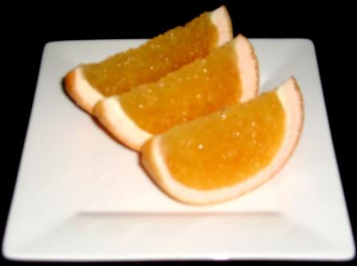
2000 ml Grapefruit Juice
200 gm sugar
15 (45 gm) Gelatin Sheets
20 ml Cointreau

