GREEN TEA BRULEE

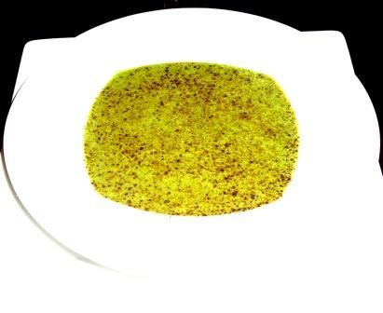
1000 ml Heavy cream
230 gm granulated sugar
15 gm Green Tea powder
30 ml water
7 egg yolks
1 whole egg
30 ml grappa

