WARABIMOCHI
Bracken Jelly

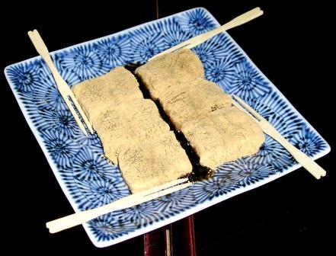
1800 cl Water
500 gm Bracken Powder
100 gm Sanontou
(a kind of brown sugar)

