CHOCOLATE MOLTEN CAKE

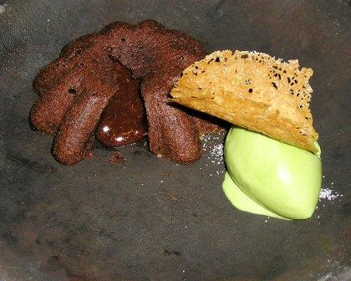
MOLTEN CAKE  - 20 Eggs  - 20 yolks  - 1 lb sugar  - 100 gm All purpose Flour  - 1 kg Valrhona Chocolate 66% “pur Caraibe”  - 1 kg butter | Whisk eggs, yolks and sugar together  Melt butter and chocolate together  Once eggs and sugar hit ribbon stage, add flour  Finally add butter and chocolate (almost hot)  Whisk until batter turns dark, finish by hand using a rubber spatula
GREEN TEA ICE CREAM
- 6 qt milk
- 4 qt ½ & ½
- 400 gm corn syrup
- 800 gm sugar
- 2 cups Matcha powder
__________
- 3 small cans (1k200)
condensed milk

LACE TUILES  - 800 gm Sugar  - 300 gm All purpose flour  - 400 gm Orange Juice  - 400 gm butter (melted and cooled) | Whisk together sugar and flour  Add orange juice  Slowly add butter to mix  Refrigerate before using  Pipe onto silpat and bake at 300 F until golden brown  Wait 1 minutes before removing from tray and shape onto Tuile gutter tray

