PASSION FRUIT SOUFFLE
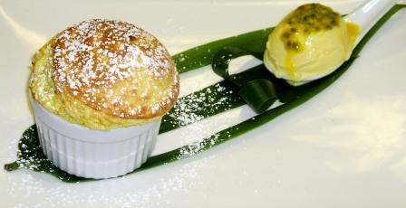
 | 1X | ¾ |  | ½ | 1/3 | ¼
Passion Fruit Puree  Pastry Cream Powder  Milk  Egg Whites  Sugar  Water | 1500 gm  200 gm  500 gm  1000 gm  1000 gm  300 gm | 1125 gm  150 gm  375 gm  750 gm  750 gm  200 gm |  | 750 gm  100 gm  250 gm  500 gm  500 gm  150 gm | 500 gm  75 gm  170 gm  340 gm  340 gm  100 gm | 375 gm  50 gm  125 gm  250 gm  250 gm  75 gm
Mix puree, milk and pastry cream powder together and bring to a boil, while continuously whisking
Add water to sugar in a sauce pan and heat to 121 C, while whipping egg whites to soft peaks.
Add sugar to egg whites and whip on high speed.
When cool, fold meringue into passion fruit pastry cream and pipe into ramequins

PASSION FRUIT ICE CREAM  - 2 liters milk  - 2 liters heavy cream  - 2 liters Passion fruit puree  - 2 kilos sugar  - 70 yolks (1 kg 400) |  |  | Bring milk, heavy cream and puree to a boil  Mix together yolks with sugar  Temper with milk mix  Make crème anglaise.
*Garnish ice cream with passion fruit seeds

