PASSION FRUIT SUNFLOWER
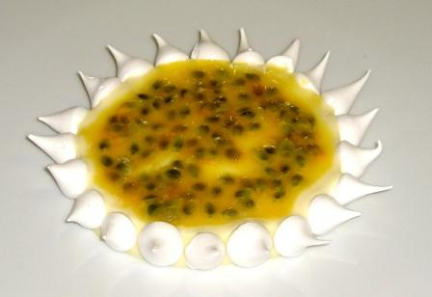
MERINGUE TIPS  - 300 gm egg whites  - 200 gm Sugar  - 1 lb Confectioners Sugar | Put all ingredients together in the mixing bowl (Kitchenaid), with the whisk on second speed. Using a blow torch, heat the bottom of the bowl while beating.  Keep doing until the egg whites become warm and fluffy.  At this point, turn the mixer onto its maximum speed and let turn until meringue become just lukewarm and stiff onto hard peak
CRÈME DIPLOMATE VANILLE  Pastry Cream  - 1 qt Milk  - 275 gm sugar  - 80 gm Pastry Cream Powder  - 2 Eggs  - 1 tBsp Orange Blossom Water | Bring milk to a boil  Temper into egg / sugar mix  Whisk constantly until boiling and bubbling
For crème diplomate Vanille  - 500 gm Pastry Cream  - 150 gm whipped cream (hard peaks) | Use paddle attachment to make pastry cream smooth  Whip the cream  Gently combine and keep in a pastry bagh ready for use

