Pavlova Passion Fruit Sorbet
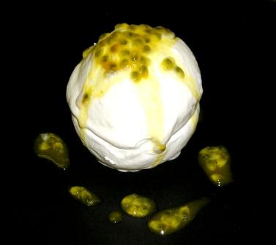

Meringue
600g egg whites
600g sugar
600g confectioner’s sugar

Whip the whites until stiff peak. Add sugar little by little. Fold in confectioner’s sugar by hand. Grease the molds. Fill the molds with meringue. Form a shell. Bake @ 150F for about 3hrs.

Passion Fruit Sorbet
3000k Passion Fruit Puree
1000k Water
3000k Simple syrup

Combine and spin.

To Serve
Passion Fruit seeds
Lightly whipped cream

Dip one meringue cup in whipped cream and put on plate. Fill with a scoop of sorbet. Dip the top of the other in lightly whipped cream. Place on top. Garnish with passion fruit seeds.

