PEACH PANCAKE “OTABE”
Red Bean Ice cream / chocolate waffer
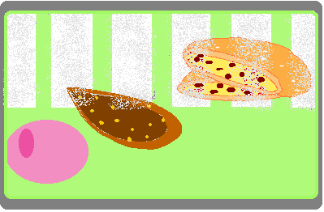

PANCAKE mix
- 12 egg yolks  - 120 gm sugar  - 120 gm flour  - 750 gm milk  - 120 gm butter  - 12 egg whites  - 75 sugar | Whisk egg yolks with sugar until very light and fluffy  Add flour and whisk until combined  Meanwhile heat milk and butter to the boil  Add hot mixture to whisking egg yolk mixture  In another bowl whisk whites with sugar and a squeeze of lemon.  Gently fold whites into warm mix  Cooking the pancake onto griddle with a lid or on small skillet.  They need to be stuffed when still lukewarm.

PREPARING THE peaches
Traditionally peel peaches using boiling water and iced bath.
Cut the fruits in halves.
Put the half peaches in a baking pan and pour a good amount of condensed milk over.
It should be enough condensed milk to coat the peaches when tossed, before going into oven.
Cover with aluminum foil and bake at 300F for about 20 to 30 min.
Once in a while , it is important to shake the pan to recoat the peaches with the condensed milk.
When bake chop the still hot peaches into morsels the size of a thumb nail.
Put back this morsels into pan, toss the fruit again and strained them while they are still hot
When the fruits are totally drained and cold, cover with a plastic wrap and keep so until needed.
The milk will be used for the red bean ice cream.

__________PEACH PANCAKE “OTABE”____ page 1__
Red Bean Ice cream / chocolate waffer

STUFFING THE pancakes
Place ½ inch thick of the baked peaches on almost the entire surface of a pancake.
Cover with another one slowly pushing down with the palm.
When order comes in, slightly –preheat the stuffed pancake in the microwave for 20 second, then flash it in the oven for a minute or less.

RED BEAN ice cream
- 4 qt milk  - 3 qt ½ & ½  - 200 gm corn syrup  - 50 gm sugar  - 15 gm Agar powder  - Azuki beans (tbd)  __________  3 small cans (1kg200) condensed milk  from drained peaches | Bring milk ½ & ½ and corn syrup to a boil.  Add sugar and Agar powder and bring back to the boil to achieve the liaison.  Add the Auki beans, mashed, blended with little of the hot liquid and strain through very fine mesh.  Finally add the condensed being used to bake the peach  Note: The amount of Azuki beans and condensed milk are still “to be determined”(tbd)

CHOCOLATE WAFFER w. candied Yuzu
Melt chocolate ready to be tempered
On plastic sheet, pipe some equal (1 inch diameter) dots of the tempered chocolate
Using the center finger, spread the chocolate as thin as possible operating in oval, almost circular motion.
Sprinkle some tiny dices of candied Yuzu.
Let set and keep in freezer for when needed.

TOOL TO design
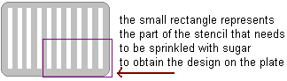

__________PEACH PANCAKE “OTABE”____ page 2 & last__
Red Bean Ice cream / chocolate waffer

