Frozen soufflé Pineapple
Souffle Port Royal
sandwiched in roasted Pineapple)
Mango coulis & cilantro syrup
____________________________________
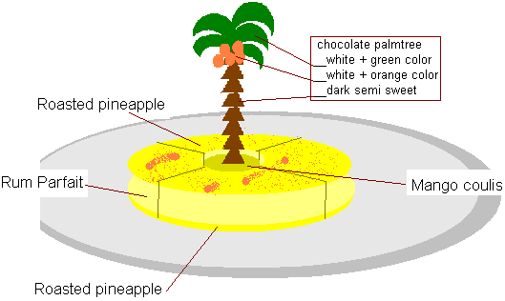

SOUFFLE
KIRSCH PARFAIT  - 1 liter (volume) Pate a Bombe Dure  (see right below for method)  - 1 ½ dl (150 gm) KIRSCH  - 2 litre (volume ) whipped cream  PATE A BOMBE DURE  - 640 gm simple syrup  - 320 gm egg yolks | _______KIRSCH PARFAIT______  Add The Rum to the Pate a Bombe  Fold in the whipped cream.  Pour the Parfait mix into empty tart ring that should be the same diameter that the pineapple slices.  Later the frozen will be unmolded and sandwiched between two thin slices of roasted slices of pineapple.  The center will be punched out as the center of the pineapple slices.  the mango coulis will take place In the middle  _____PATE A BOMBE DURE_____  Cook, the syrup at 110°C (234°F), pour it over the beating yolks on high speed and let work until totally cooled.

PINEAPPLE
Golden Pineapple __________________________  Red Currants ______________________________  Elderberries _______________________________ | ¼ thick slices of pineapple (2 per portion)  Roasted with dot of butter, sugar and seeds of fresh vanilla bean.  Make wet with water / egg white solution _just wet _shake if necessary.  (1 pint water for 1 white, whipped until foam forms on surface, remove foam and proceed.)  Finally roll berries in superfine semolina sugar and lay on parchment paper. Need to be done at least 1 hour before to obtain crispiness.

SAUCES
MANGO COULIS _________________________  CILANTRO SYRUP ________________________ | Frozen mango puree with lime juice added until just perceptible.  Cilantro, blanched, cooled and drained.  Finally blended in fresh golden pineapple juice

_________ Frozen soufflé Pineapple__page2_____
Souffle Port Royal

