RASPBERRY CRISP NAPOLEON
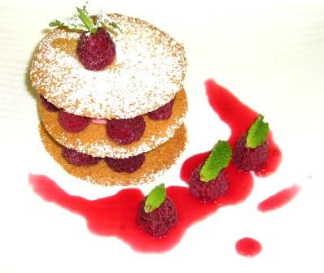
FRANGIPANE CRISP  - 1 lb Butter (creamy)  - 1 lb Confectioners Sugar  - 1 lb Blanched Almond Flour  - 10 Eggs (cold)  - 1 tbsp Dark Rum | Put the first three ingredients , butter first. Cover the butter with the sugar and almond flour Crack the eggs over the almond flour and turn on first speed for 10 seconds, second speed for 5 seconds, third speed for 10 seconds Put back then onto second speed until the mix becomes fluffy until clear yellow color  Finally add the Rum , and a couple of more turns
RASPBERRY MOUSSE  Base  - 1 kg Raspberry puree  - 500 gm Sugar  - 11 gelatin Sheets | Heat Sugar and raspberry puree  Add gelatin  Keep in fridge until needed  Take 375 gm of this base, put it in the microwave or over a double boiler to soften it (not liquid)  And add 375 gm of whipped cream (firm and cold)
RASPBERRY SYRUP with Woodberry Tea  - 1 kg 200 Fresh Raspberries  - 1 kg Sugar  - 200 gm light Corn Syrup  - 200 gm water  - 2 cups Woodberry Tea | Boil sugar and syrup with water and let cook until reaching the level of the “Hard ball” or 121 C  Add the raspberries and let simmer for 15 minutes or until they entirely fall apart  Strain and bring back to the boil, add the Tea, turn off flame and let infuse, covered for 30 minutes  Strain again but keep the Tea for a next time during which you will be adding some unused one.
*Use Fresh Raspberries for garnish

