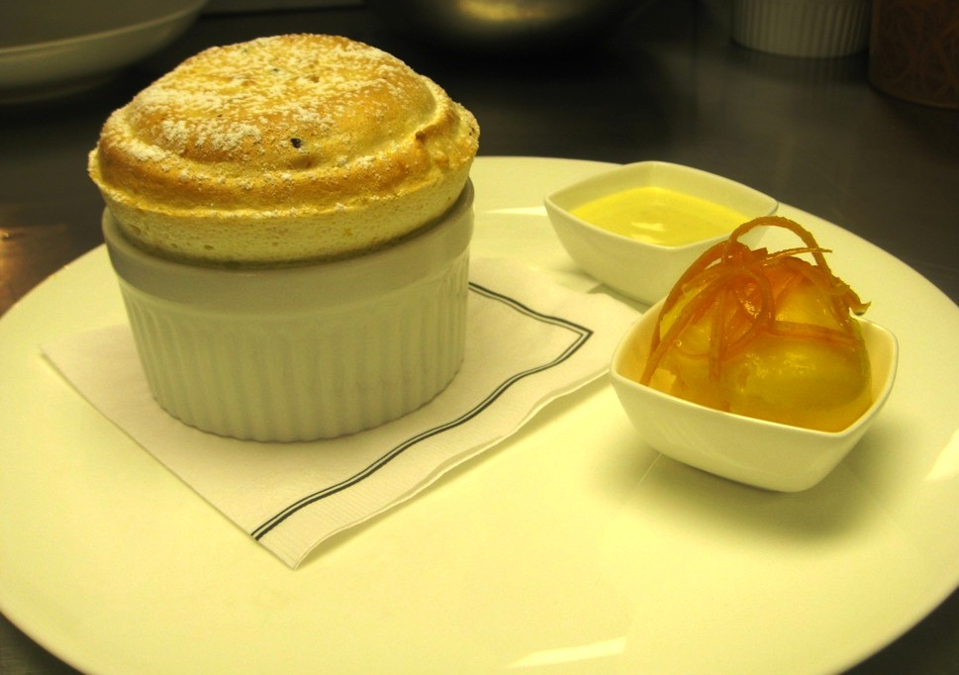
 | 1X | ¾ | ½ | 1/3 | ¼
Orange Juice  Orange Zest  Lemon Juice  Pastry Cream Powder  Grand_Marnier  Egg Whites  Sugar  Water | 1900 gm  5  300 gm  200 gm  250 gm  1000 gm  1000 gm  300 gm | 1200 g  4  225 gm  150 gm  200 gm  750 gm  750 gm  200 gm | 800 gm  3  150 gm  100 gm  150 gm  500 gm  500 gm  150 gm | 540 gm  2  100 gm  75 gm  100 gm  340 gm  340 gm  100 gm | 400 gm  1  50 gm  50 gm  50 gm  250 gm  250 gm  75 gm
Chocolate Chips |  |  | 300 gm | 190 gm | 150 gm
YIELD: | - | - | 18 to 20 | 13 to 15 | 9
Mix juice and pastry cream powder together and bring to a boil, while continuously whisking
Add water to sugar in a sauce pan and heat to 121 C, while whipping egg whites to soft peaks.
Add sugar to egg whites and whip on high speed.
When cool, fold meringue into orange pastry cream , add the HOMEMADE Chocolate Chips 9using Valrhôna 66% “Pur Caraïbe ) and pipe into ramequins
MANDARIN SORBET
- 1 liter mandarin orange juice
- 50 gm fresh Lemon Juice

- 40 gm Trimoline
- 200 gm Sugar
- 150 gm water

