Strawberry Club

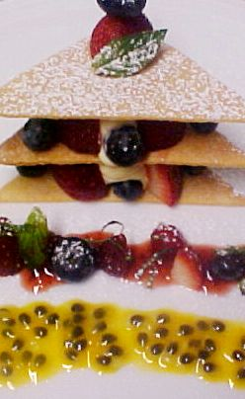
Dough  1000 butter  840 powdered sugar  2500 all purpose flour | Cream butter and sugar on 2nd speed. Add flour and mix on 1st speed until just incorporated, then finish by hand. Roll out thin and cut dough into triangles before baking. Put small hole in top of 90° corner. Cook at 160° for 10 min.
Pastry Cream  500 g. milk  75 g. poudre la creme  500 g. passion fruit puree  225 g. sugar  whipped cream | Bring milk to a boil. Mix poudre la creme, sugar and passion puree in a bowl. Add milk then return to fire and cook until thickened. Let cool and add ¾ parts whipped cream to 1 part pastry cream.
To Serve  Fresh passion seeds  fresh strawberry | Place on triangle on plate. Top with strawberries in the corners and cream in center. Repeat and top with cookie. Make sure the holes in the cookies line up and drive a skewer all the way down. Spike skewer with a strawberry. Garnish plate with passion fruit seeds.

Strawberry Club

