_____STRAWBERRY NAPOLEON_____
THE PUFF PASTRY “ ARLETTE”  - 1 kg AP flour  - 20 gm Salt  - 550 gm cold water  - 225 gm butter  - 2 lb butter  _______________________  - 10 X (when rolling the dough) | 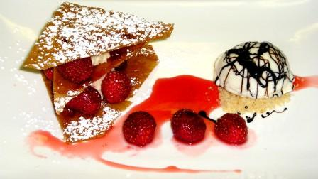
COCONUT CREAM  - 240 gm 10 X  - 480 gm grated coconut  - 1200 gm whipped cream to soft peak  - 1/3 cup Malibu Rum | Mix sugar and coco. Fold in whipped cream. Season with Malibu.
STRAWBERRY SYRUP
- 1 kg 600 strawberries
- 600 gm sugar
- 1 orange
- 3 vanilla beans
- 20 gm corn starch + 20 gm cold water

TOFU ICE CREAM
- 1 kg soft Tofu
- 250 gm condensed milk
served with
- reduction of balsamic vinegar

TO SERVE
- ARLETTE
- COCONUT CREAM
- FRESH STRAWBERRIES
- STRAWBERRY SYRUP
- TOFU ICE CREAM
- BALSAMIC REDUCTION
- FREESH MINT LEAVES

_____STRAWBERRY NAPOLEON_____

