THAI SUNDAY
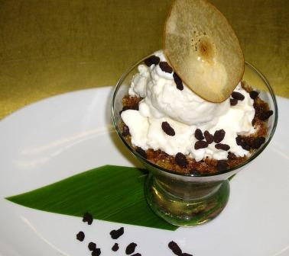
CHOCOLATE CREAM  - 500 gm Milk  - 500 gm Heavy Cream  - 500 gm Chocolate 66% “Pur Caraibe”  - 10 yolks  - 150 gm Sugar | Bring milk and cream to a boil  Mix yolks and sugar  Proceed like regular crème Anglaise  Strain hot mix onto chocolate, stir until melted
ESPRESSO GRANITA  - 500 gm Espresso Coffee  - 100 gm Simple Syrup | Add more or less syrup as needed
RICE CRISPIES  - 200 gm Sugar  - 50 gm Rice Crispies  - 100 gm Tempered Chocolate | Caramelize the sugar (light caramel)  Add the rice crispies and stir  Cool and add chocolate  Put in cocoa powder after chocolate sets.
RICE PUDDING ICE CREAM  - 1 qt milk  - 75 gm Jasmine rice  - 20 gm Sugar  _________________  - 2 ½ quart Half & Half  - 100 gm light corn syrup  - 1 small can (400 gm)condensed milk  - 200 gm Sugar  - 5 gm Agar Powder | Wash rice in strainer under cold water  Bring milk to a boil and add rice and sugar  Bring back to simmering for 1 minute and remove from heat  Keep covered  Bring half & half to a boil  Add corn syrup and condensed ilk  While, constantly whisking, add sugar and stabilizer  Wait for boil and then remove from heat
*For garnish, use Asian pear chip*

