__________TRI-STAR STRAWBERRY__________
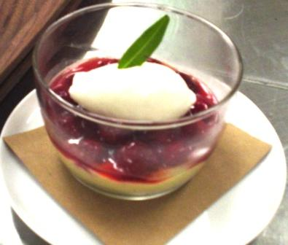
- twice baked butter cookie dough
- Lemon “Chibouste” cream (lemon custard with meringue added)
- Tri-star Strawberries (small local strawberries)
- Syrup made with the infusions of strawberries / sugar / Orange rinds / vanilla beans.
- Lemon Verbena sorbet
COOKIE “PETIT BEURRE”
- 950 gm AP flour  - 450 gm Confectioners sugar  - 550 gm Blanched almond flour  - 550 gm soft butter  __________  - 425 gm cold butter | Mix by hand flour / sugar / almond flour and butter until “sablé”  Pass through a fine sieve or tamis.  Spread the crumble over a tray and cook at 300 F until golden brown.  Let cool completely.  Pulverize this cooked dough in robot coupe.  In the mixing bowl using the paddle  attachment, add the second amount of butter (cold) and let work until “sablé”.

LEMON CHIBOUSTE X 5 = 102 portions
- 190 gm lemon juice  - 125 gm heavy cream  - 8 egg yolks  - 50 gm sugar  - 25 gm flour  __________  - 8 leaves gelatin  __________  - 8 egg whites  - 125 gm sugar  - 25 gm corn syrup | Make the pastry cream using the five first ingredients.  Add the gelatin before the boiling point  With the three last ingredients, make a meringue,” Italienne” technique.  Fold the meringue into pastry cream.

STRAWBERRY SYRUP
- 1kg600 TriStar Strawberries
- 600 gm sugar
- 1 orange
- 3 vanilla beans

- ____cornstarch
- ____water

LEMON VERBENA SORBET
- 200 grs sugar  - 200 grs water  - 1 bunch lemon verbena  - 2 lemons juiced  - 1/8 liter Pellegrino  - 1 egg white | Bring water and sugar to a boil  Add lemon verbena  Let cool, blend for 10 seconds and strain  Add Pellegrino, egg white and turn

__________TRI-STAR STRAWBERRY__________

