VALRHONA MOLTEN CAKE
yield: 18 to 20 pieces

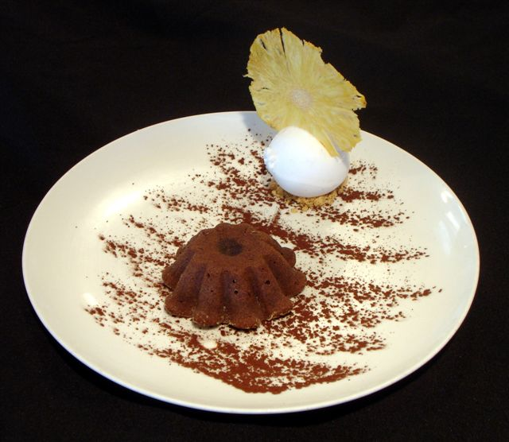

- 1,2 lb(500 gm) 66% Chocolate (semi-sweet)  - 1,2 lb (500 gm) butter  - 10 egg yolks  - 10 whole eggs  - ½ lb (225 gm) sugar  - 3 oz (80 gm) all purp. Flour | Before greasing the molds with using a pastry brush, it is necessary to chill them in the fridge or freezer .  Then repeat the operation , after this second time we need to slightly flour them  Then put them back in the fridge until the mix is ready .  Primarily melt chocolate and butter together over a double boiler  In the mixer, mix together on 2nd speed yolks eggs and sugar until light and forming a ribbon (like sponge cake )  Add the chocolate/butter mix let incorporate slowly , then add the sifted flour into the mixer . Finish homogenizing using a rubber spatula.  Pour right away into the floured molds, using a ladle  Keep in the fridge until ready to be baked at 350ºF for 7 to 9 min .
VANILLA ICE CREAM  - 1 qt milk  - 1 cup heavy cream  - 2 vanilla beans  - 12 egg yolks  - ½ lbs sugar  - 4 gm Agar powder | _____CRÈME ANGLAISE_____  Bring the milk and cream to a boil a first time infusing the vanilla beans (do the same if you use vanilla extract)  Beating energetically using a wire whisk, combine yolks and sugar until it turn into lemon color.  Remove the boiling liquid from the flame  Pour some of the boiling liquid over the egg /sugar mixture, mix well and add this mixture back to the remaining boiled liquid.  Put the pan back on the stove over medium heat .  By using a wooden spoon, gently finish cooking the crème anglaise until thick enough to cover the back of the spoon.  The safest way remains to use a thermometer. In this case, turn off the flame when the mixture reaches 84 C Strain immediately into a bowl over a bath of ice.  TIP: by tracing a line with a finger on the cream coated spoon, we should see this line remaining still.

______________________
VALRHONA MOLTEN CAKE

