Warm Madeleines
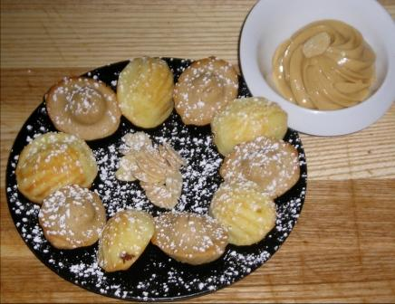

Madeleines
-20 Eggs –Whisk eggs to ribbon stage and add sugar
-800g Sugar –Add milk and butter
-300g Milk -Mix baking powder into flour
-500g Butter (melted) –Fold dry into wet
-1K A.P. Flour (sifted)
-20g Baking Powder

*For pistachio and praline flavors, divide batter into two bowls of 1K 800g of batter and add 200g of praline to one bowl and 200g of pistachio to the other. Mix to incorporate.

Milk Marmalade
-4 Cans of Coconut Milk -Bring vanilla beans and coconut milk
-4 Cans of Evaporated Milk a boil
-4 Cans of Condensed Milk -Add the evaporated milk and boil
-4 Vanilla Beans -Add condensed milk and constantly
stir until boiling again
-Reduce until color changes to clear
golden

* For garnish, use O.B.Almonds

